

DEVOPS FUNDAMENTALS AND SCM LAB

School of Computer Science

|  |  |
| --- | --- |
| *Submitted To:* | *Submitted By:* |
| DR. ARJUN ARORA | AKSH CHAUHAN  Batch No. 1 (DEVOPS)  Roll. No. R2142230601  Sap. ID. 500120187 |

**EXPERIMENT-1**

**Steps to Install Git on Windows**

1. Download Git
   * Go to [Git official site](https://git-scm.com/downloads)
   * Click Windows → Download the latest version.

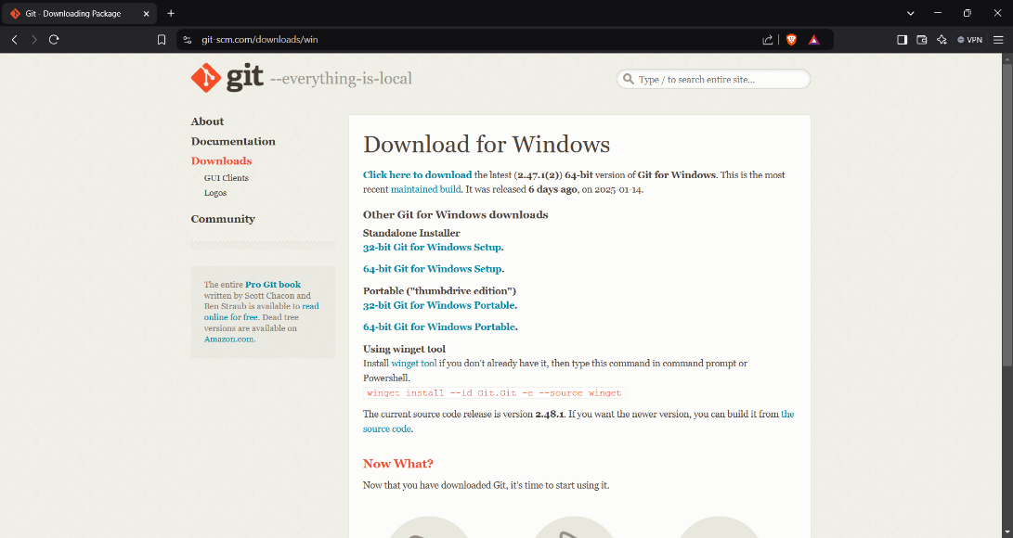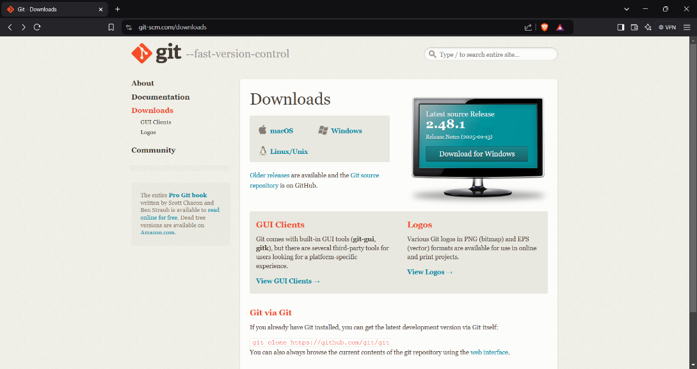

1. Run the Installer
   * Open the downloaded .exe file.
   * Click Next on the setup wizard.

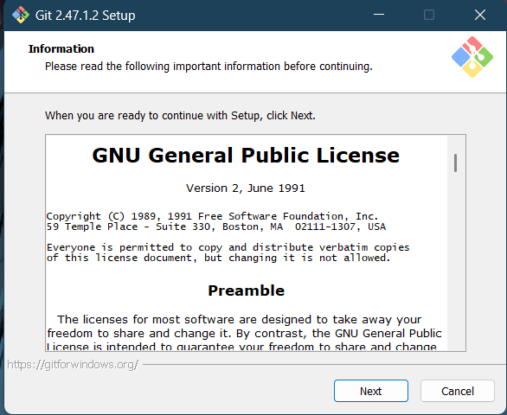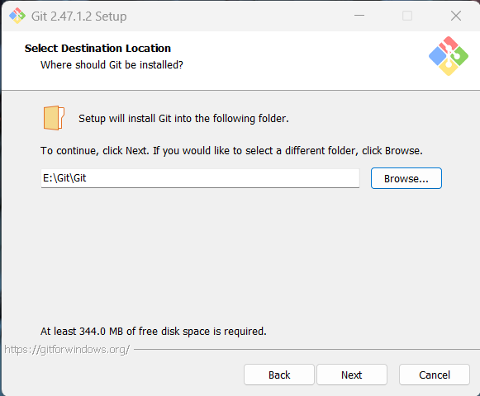

1. Choose Installation Options
   * Select Destination Folder → Click Next.
   * Select Components → Click Next.
   * Choose Default Editor → Click Next.
   * Adjust PATH Environment → Choose "Git from the command line and also from 3rd-party software" → Click Next.
   * Choose HTTPS transport backend → Keep default OpenSSL → Click Next.
   * Choose Line Ending Conversion → Keep default → Click Next.

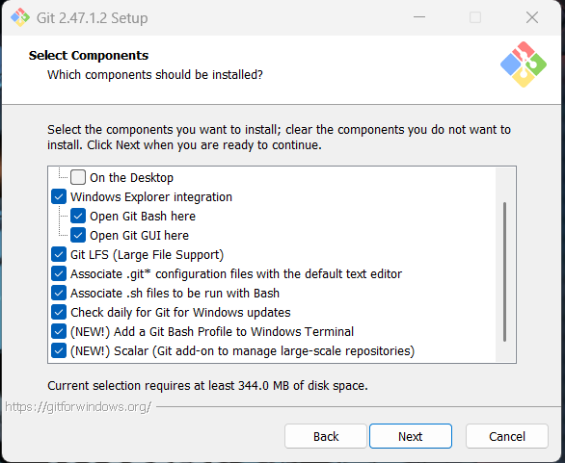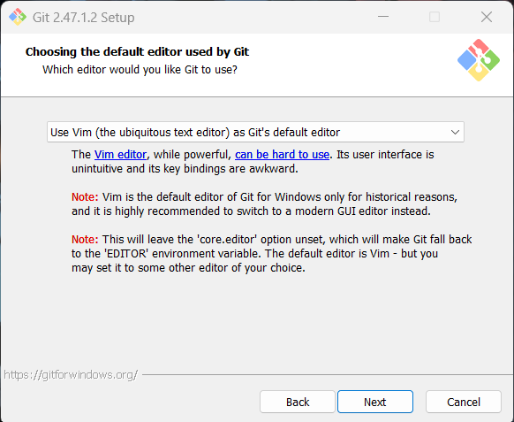

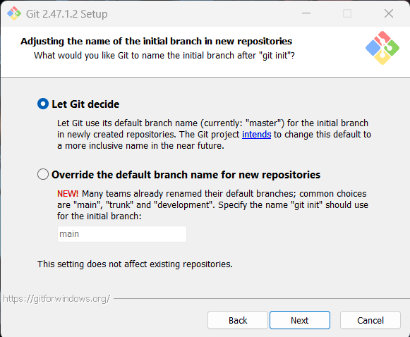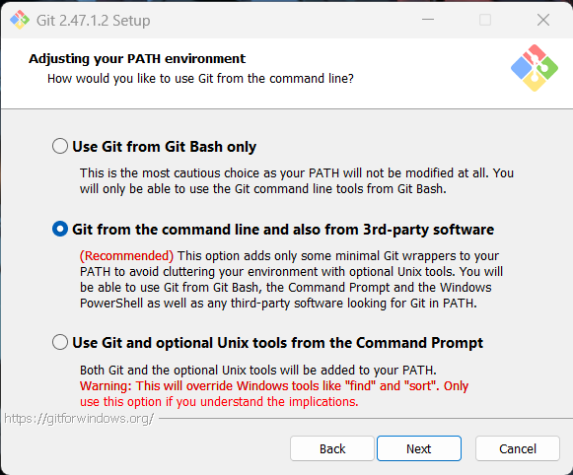

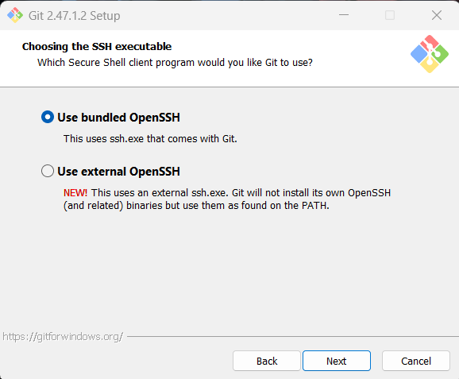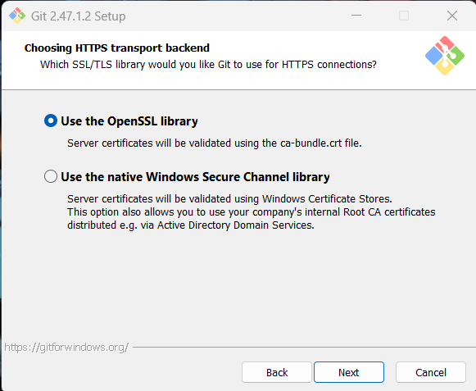

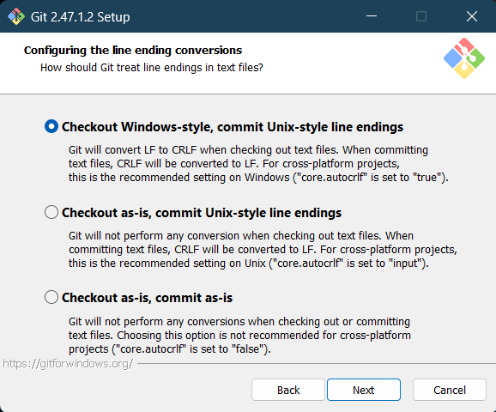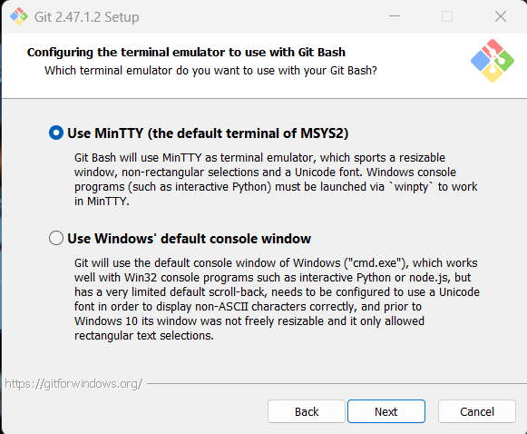

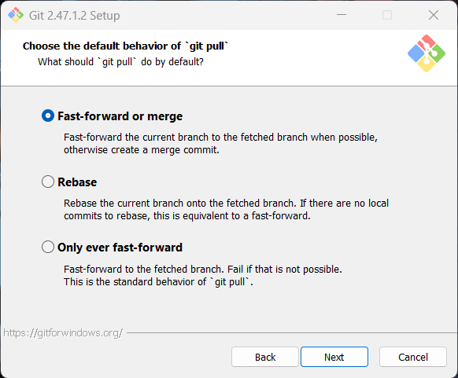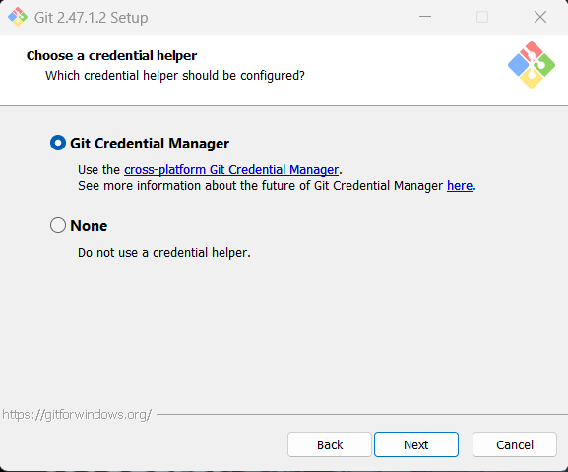

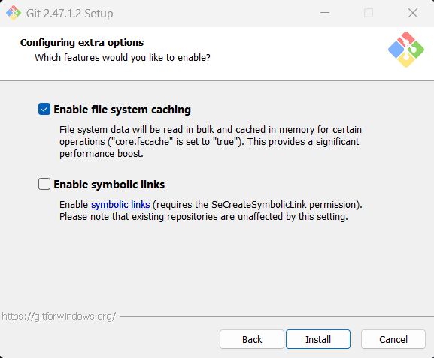

1. Finish Installation
   * Click Install and wait for the process to complete.
   * Click Finish to close the setup.

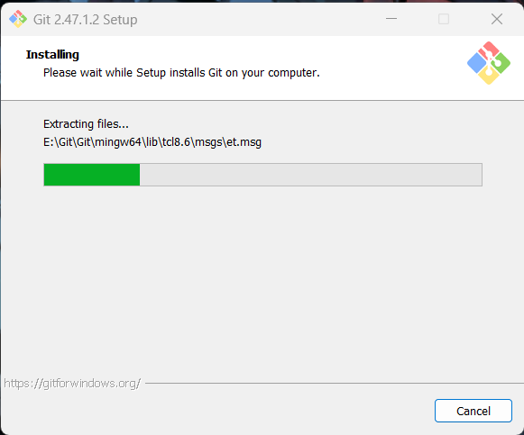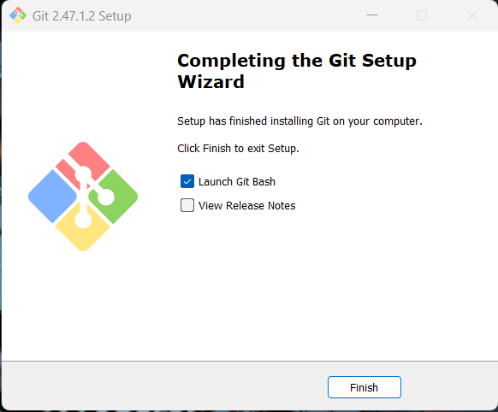

1. Verify Installation
   * Open Command Prompt or Git Bash.
   * Type: git --version
   * If installed correctly, it will show the Git version.

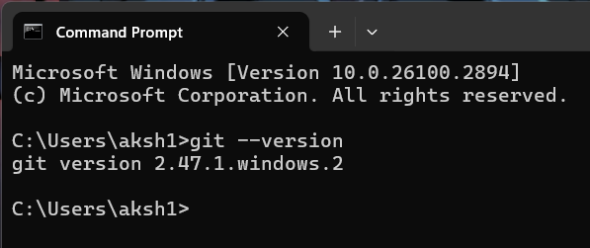

**Steps for GitHub Profile Creation**

1. Sign Up on GitHub ([GitHub.com](https://github.com/)) → Enter Username, Email, Password → Verify email.

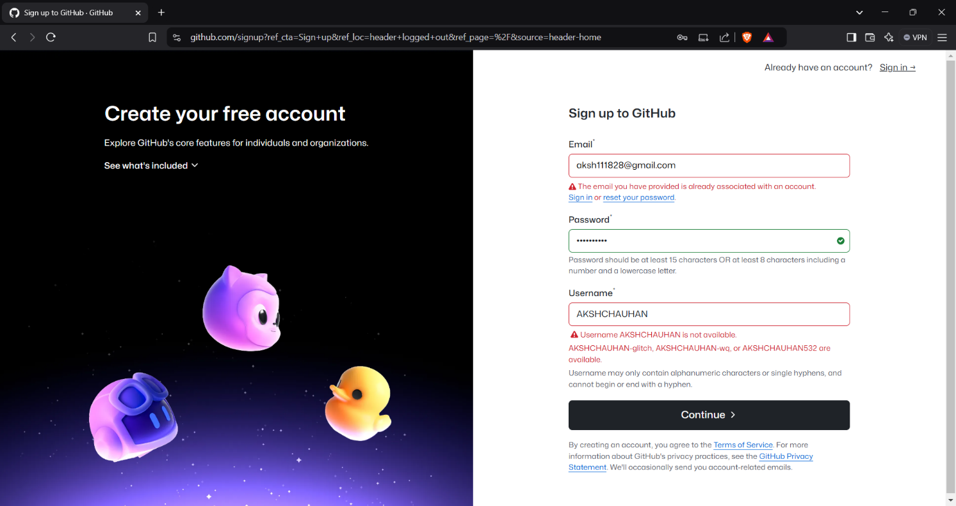

1. Edit Profile → Click on Profile Picture → "Your profile" → "Edit profile" → Add Name, Bio, Location → Save.

